# Homework #5: Active Directory and Group Policy Objects

|  |
| --- |
| * This is an individual assignment, and is worth 20 points. * The due date is Thursday, March 1st. * You need to provide your answers to the “Homework #5 – Tasks.docx” file. Change the file name following the naming convention suggested below. * Naming convention is as follows: homework, underscore, last name, first initial, and extension (e.g., Homework #5_ImG.docx). * Do not copy any of the sample screenshots provided as illustrations. |

* (**Task 1**) Show in a screenshot that the three domain users (sqluser1, sqluser2, sqluser3) are created in **SQLUsers** OU. Also show in a screenshot that **sqlgroup** is created in the **Groups** OU.

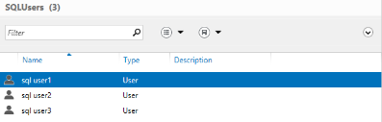

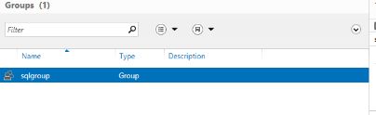

* (**Task 2**) Go to sqluser1 properties and show in a screenshot that sqluser1 is a member of **Domain Admins** and **sqlgroup**.

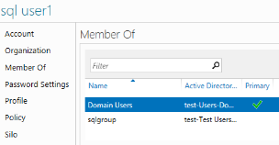

* (**Task 3**) Run the following query on SQL Server and show in a screenshot that you indeed logged-on with sqluser1.

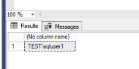

* (**Task 4**) Logon to SQL Server. Create a login “**BigUser1**”. Select **SQL Server authentication**. Enter the password “1234567”, and show in a screenshot that the login cannot be created. Explain why?

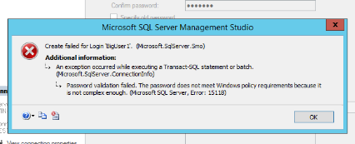

The reason you cannot create this login is because the windows password complexity policy will not allow it.

* (**Task 5**) Create a login “**BigUser2**”. Select **SQL Server authentication**. Enter the password “1234567”, and show in a screenshot that the login is created. Explain why this was possible. Explain also the relationship between the GPO and the SQL Server password policy.

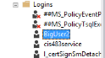

The login is created because I disabled the windows password complexity policy. The GPO that is on the domain controller is adopted by the SQL instance on this system because when creating a SQL login to connect to SQL Server you can turn on check policy which enforces the windows password policy.